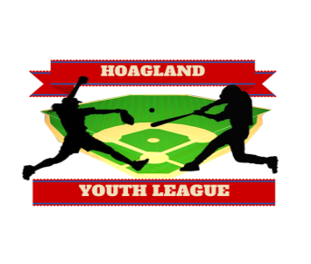

**2025 Hoagland Youth League Sponsorship**

**Opportunities**

The Hoagland Youth League (HYL) is an organization that was formed to offer all area youth the opportunity to participate in sporting activities to develop athletic skills as well as good sportsmanship. HYL would not be able to offer this opportunity to the youth of our community without the active involvement of business leaders, area churches, and charitable organizations such as HAAA as well as individuals interested in furthering our children’s futures. Please review the opportunities listed below to sponsor a team or an outfield fence sign. Please check the box for which program you may be interested in sponsoring.

**Team Sponsor - Sponsors name to appear on uniform. Team plaque will be provided.**

T-Ball--------------------------------$275

8U divisions -----------------------$300

Minor/ Major Boys & Girls -----$325

Koufax division -------------------$350

Team Request______________________________________________________

**Outfield Sign Sponsor- First year-includes graphic set up, print and sign board.**

First year--------$200 or $400 for a three year commitment with new sign purchase.

### Renewal---------$125 annual

**Package:**

**Team Sponsor + Outfield Sign = $25 discount (renewal or first time)**

**Sponsor Name______________________________________________**

# Total Purchase: $_______________

# 

# Discount $_______________

# Check Payable to HYL in the amount of: $_______________

**(Sponsorship fees due by March 15th in order to purchase uniforms)**

**Business Name______________________Contact Person & #/email_______________________________**

**Send Payment to:** HYL **Questions?** Please email Lorie Krauss @ loriekrauss@hotmail.com

PO BOX 49

Hoagland, IN 47645